MULTILEVEL INHERITANCE:

class SuperClass:

def super_method(self):

Print(“2213711058039”)

print("Super Class method called super class")

class DerivedClass1(SuperClass):

def derived1_method(self):

print("Derived class 1 method called derived method")

class DerivedClass2(DerivedClass1):

def derived2_method(self):

print("Derived class 2 method called derived method2")

d2 = DerivedClass2()

d2.super_method()

d2.derived1_method()

d2.derived2_method()

OUTPUT:

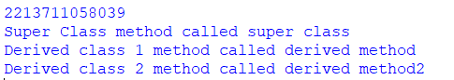

FIBONACCI SEQUENCES

def fibonacci(n):

fib_sequence = [0, 1]

while len(fib_sequence) < n:

fib_sequence.append(fib_sequence[-1] + fib_sequence[-2])

return fib_sequence

n = 10

result = fibonacci(n)

print(f"Fibonacci sequence of the first {n} numbers: {result}")

OUTPUT:



INHERITANCE

SINGLE INHERITANCE:

class Operation:

A=50

B=10

def add(self):

sum=self.A+self.B

print("sum of a and b is: " ,sum)

class Myclass(Operation):

C=50

D=10

def sub(self):

subt=self.C-self.D

print("sub of a and b is: " ,subt)

Ob=Myclass()

Ob.add()

Ob.sub()

OUTPUT:

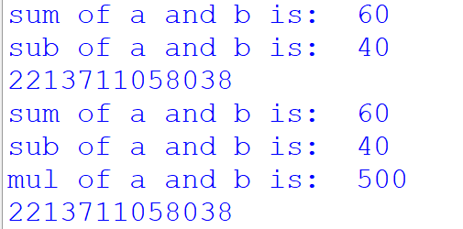

MULTIPLE INHERITANCE:

class Addition:

A=50

B=10

def add(self):

sum=self.A+self.B

print("sum of a and b is: " ,sum)

class Subtraction(Addition):

def sub(self):

subt=self.A-self.B

print("sub of a and b is: " ,subt)

class Multiplication(Subtraction):

def mul(self):

mul=self.B*self.A

print("mul of a and b is: " ,mul)

Ob=Multiplication()

Ob.add()

Ob.sub()

Ob.mul()

OUTPUT:

